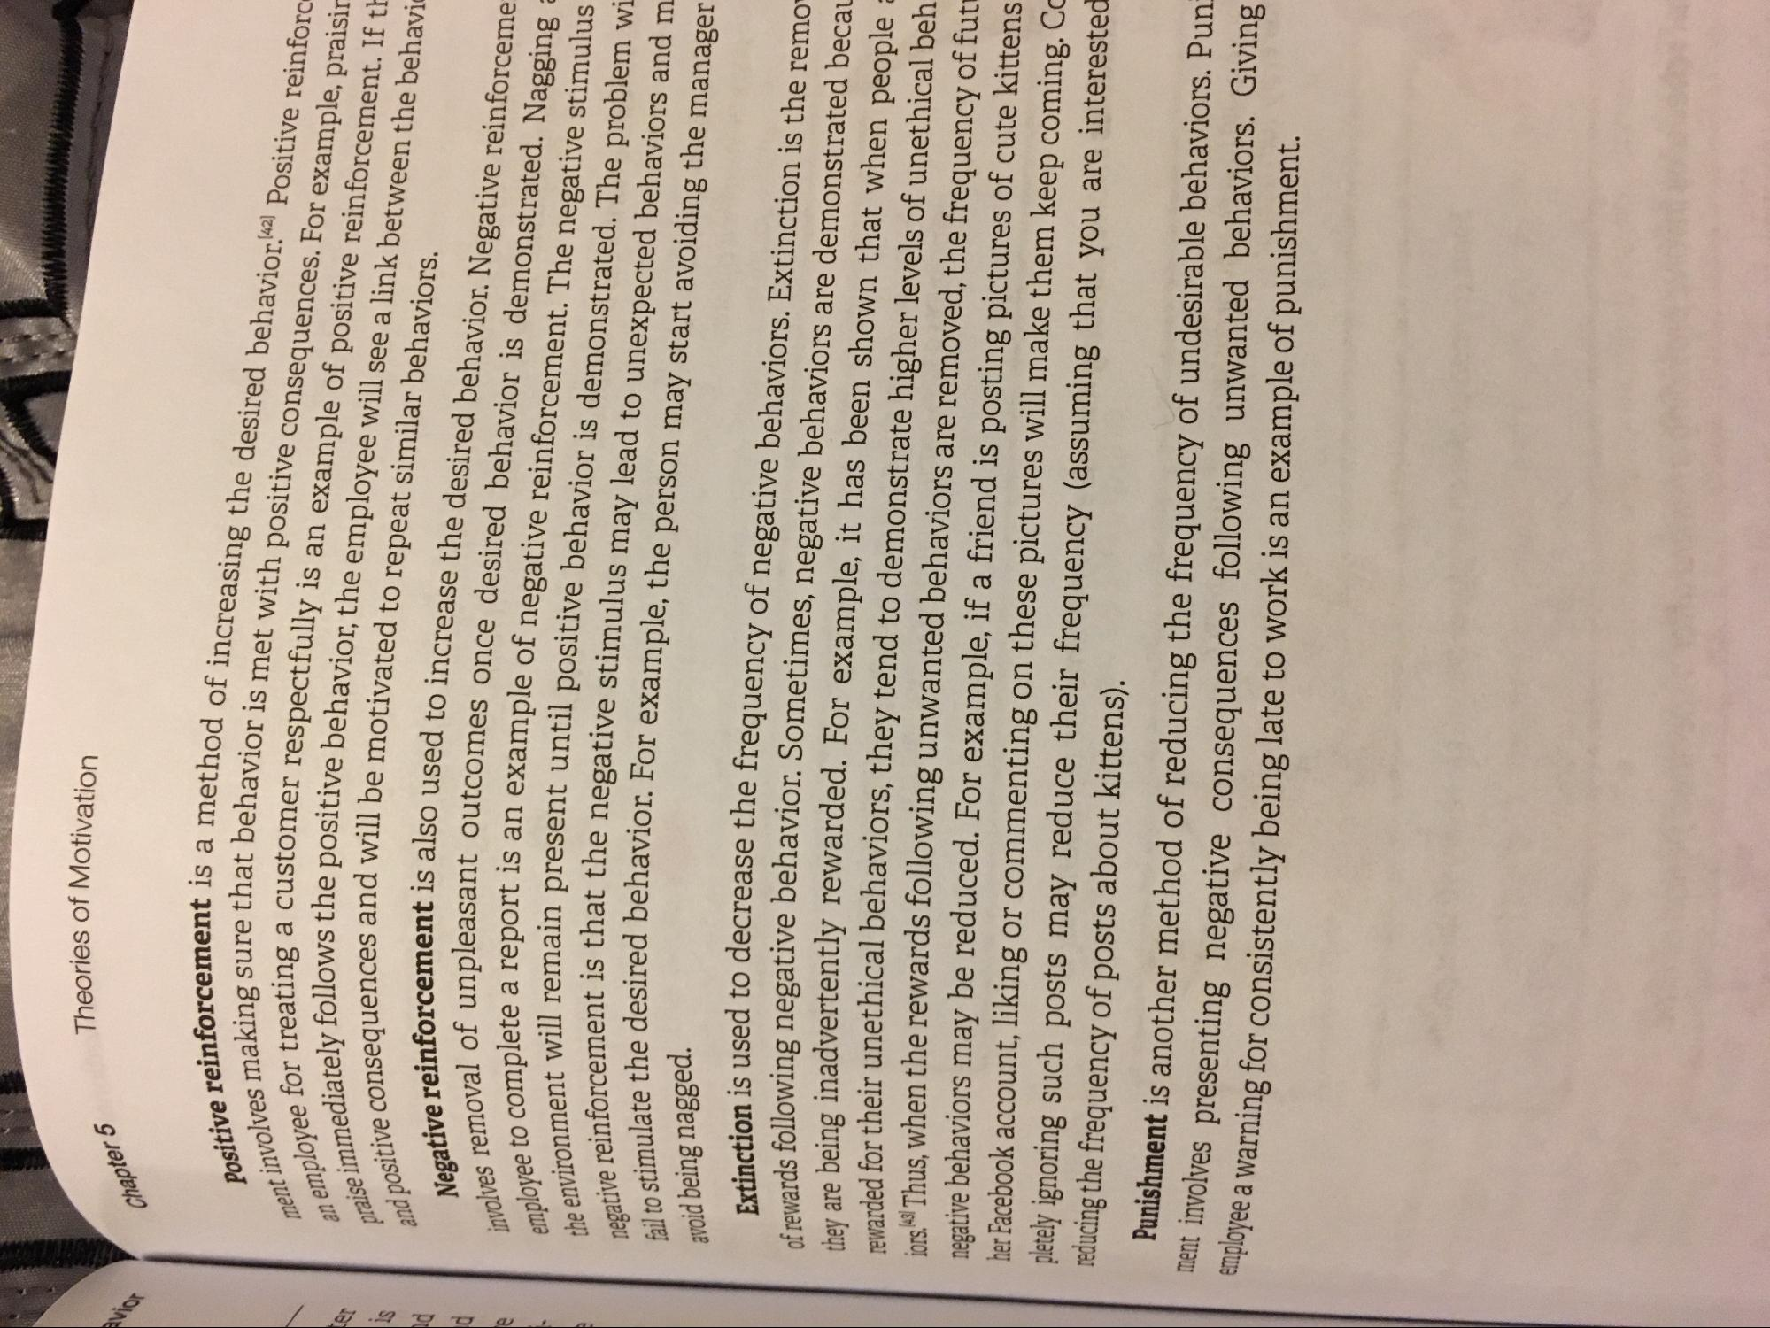
Then
Theories of Motivation
Chapter 5
ment involves
anc
praise immed
Positive reinforcement ;
involves making sure that I n employee for treating a
immediately follows the posit and positive consequences and
Negative reinforcement, volves removal of unpleasant employee to complete a rer the environment will remain prese negative reinforcement is th: fail to stimulate the desired beha avoid being nagged.
Moot is a method of increasing the desired behavior. 42) Positive reinforc ime that behavior is met with positive consequences. For example, praisir
a customer respectfully is an example of positive reinforcement. If th us the positive behavior, the employee will see a link between the behavi nees and will be motivated to repeat similar behaviors. moment is also used to increase the desired behavior. Negative reinforceme
inpleasant outcomes once desired behavior is demonstrated. Nagging to a report is an example of negative reinforcement. The negative stimulus
remain present until positive behavior is demonstrated. The problem wi ment is that the negative stimulus may lead to unexpected behaviors and m
desired behavior. For example, the person may start avoiding the manager
Extinction is used to decrease ti of rewards following negative behavior
is used to decrease the frequency of negative behaviors. Extinction is the remo
wing negative behavior. Sometimes, negative behaviors are demonstrated becau
no inadvertently rewarded. For example, it has been shown that when people nded for their unethical behaviors, they tend to demonstrate higher levels of unethical beh rolesl Thus, when the rewards following unwanted behaviors are removed, the frequency of fut negative behaviors may be reduced. For example, if a friend is posting pictures of cute kittens her Facebook account, liking or commenting on these pictures will make them keep coming. C pletely ignoring such posts may reduce their frequency (assuming that you are intereste reducing the frequency of posts about kittens).
Punishment is another method of reducing the frequency of undesirable behaviors. Pun elit involves presenting negative consequences following unwanted behaviors. Giving puyee a warning for consistently being late to work is an example of punishment.
010

